**TREE-AI**

**Why TREE-AI?**

I am thrilled to present the TREE-AI project, a ground-breaking initiative designed to revolutionize forest management and address critical challenges faced by the forestry department. This innovative solution promises to bring about substantial improvements in various aspects, offering a comprehensive approach to safeguard our forests and enhance sustainability.

* **Precision Tree Counting**
  + - **Tree Population Accuracy:**
      * Forestry department struggles with the accuracy of tree population data using traditional sampling.
      * TREE-AI employs advanced technologies for precise and real-time tree number assessments.
    - **Ecosystem Understanding:**
      * TREE-AI provides detailed insights into tree density and variance, enhancing understanding of forest ecosystems.
    - **Decision-Making Efficiency:**
      * Real-time tree population data from TREE-AI enables quicker and more informed decision-making in forestry management.
* **Combating Smuggling and Illegal Deforestation:** 
  + - TREE-AI is a powerful tool against smuggling and deforestation threats.
    - Real-time monitoring allows prompt detection and response to illegal activities.
    - Specifically addresses issues like sandalwood smuggling for comprehensive forest protection.
* **Disease Eradication and Real-time Monitoring:** 
  + - TREE-AI utilizes advanced Computer Vision and Machine Learning for real-time disease tracking in trees.
    - Continuous updates on disease patterns are delivered through a user-friendly interface.
    - Enables the forestry department to take timely and informed actions for damage mitigation.
    - Proactive approach minimizes economic losses and supports overall forest health.
* **Data-Driven Policy Design:** 
  + - TREE-AI is pivotal in shaping evidence-based policy decisions beyond its operational benefits.
    - Generated data supports the design of effective government policies on climate change, sustainable forestry practices, and crop sowing patterns.
    - Mitigates environmental risks and contributes to fostering a more resilient ecosystem.

As we move forward with the TREE-AI project, we are confident that its implementation will lead to a paradigm shift in the way we manage our forests. The integration of Computer Vision and Drone technology not only addresses current challenges but also positions us at the forefront of sustainable and data-driven forest management.

Now Let’s Discuss the process of training a CNN Model:-

**Data Collection**

The Process of data Collection is Laborious to say the least and requires a strict standard of image Quality, Resolution, Labelling. Which we have listed below:-

* **Resolution Standardization for Diverse Cameras:**
  + - 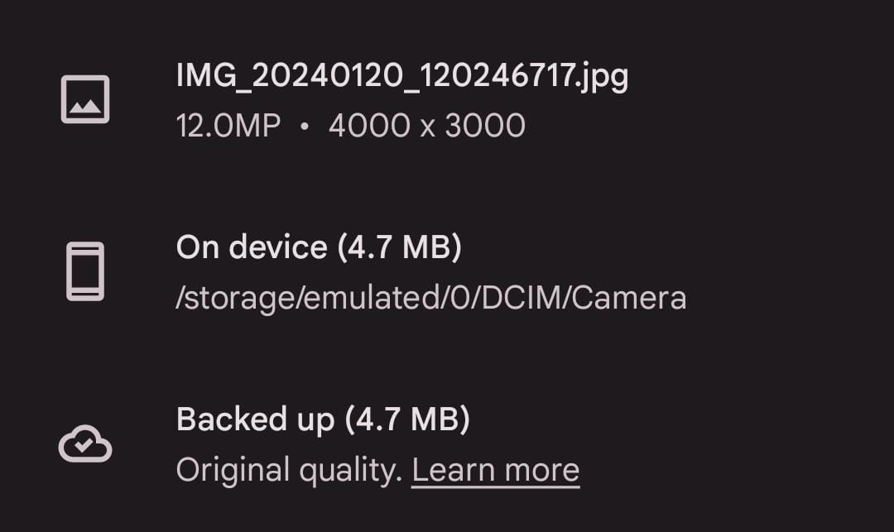To ensure consistency across diverse cameras, all images will be standardized to a 12MP resolution (4000x3000 pixels).This 12MP image will be used for Training.
      * 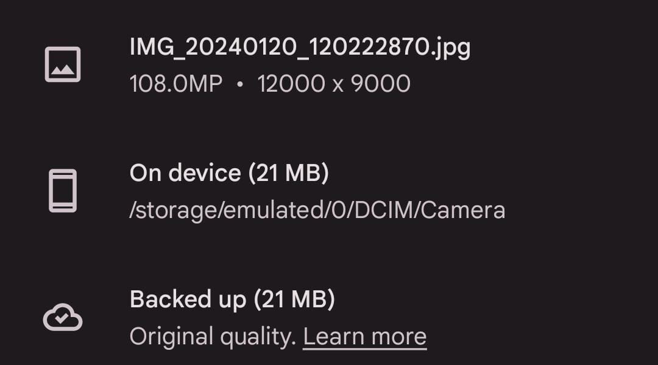Optionally, a higher resolution of 108MP (12000x9000 pixels) will be supported for enhanced detail, facilitating standardized training data for the model.

This 108MP image will be used for Validation.

* + - * Standardizing resolutions ensures a consistent dataset, promoting uniformity in training
* It also helps in Vertical integration of model as when we integrate this model to Drone we will know what kind of camera which we have to pick.
* 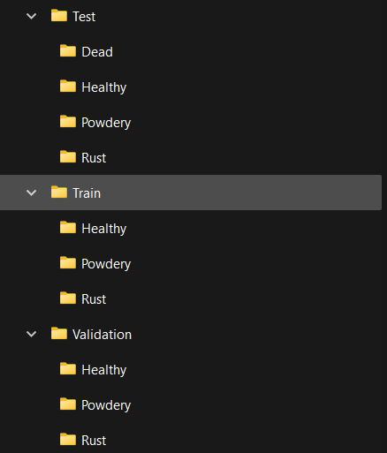**Labelling of the image:**
* This is the another Crucial part of CNN model to have well labelled image so that python code can train and validate its model according to the labels
* I have attached an image for a General Model which we trained over the weekend. And its directory Structure.
* It would be advised from our end that you follow the Given Directory System to make the data sets.
  + - 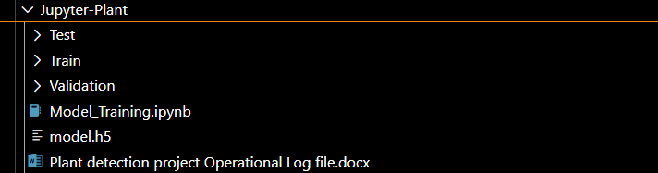I have attached the directory in which we will need the images along with ReadMe file.
* **Creation of DATA SET:**
* Each Species has around 6-9 Disease, for each Disease at present we will need around 100-150 images, which makes the required image count to be:-
* **Training File:-**
  + 4 Species * 5 Disease * 100 images * 4MB = **8GB (~)**
* **Validation File:-**
  + 4 Species * 5 Disease * 50 images *20MB= **20GB (~)**

**Training Model**

* **CNN Architecture:**
  + **Feature Extraction:**
    - * Utilizes Convolutional Neural Network (CNN) architecture for effective feature extraction.
      * Leverages multiple convolutional layers to capture hierarchical features in plant disease images.
  + **Pooling Layers:**
    - * Integrates pooling layers for down-sampling, enhancing computational efficiency.
      * Enables the model to retain essential information while reducing spatial dimensions.
* **Compilation of Model:**
  + **Optimizer and Loss Function:**
    - * Adopts Adam optimizer for efficient gradient descent during training.
      * Implements a suitable loss function, such as categorical cross entropy, to optimize model parameters.
  + **Learning Rate Adjustment:** 
    - * Incorporates dynamic learning rate adjustments to enhance convergence during model training.
      * Ensures optimal model performance by fine-tuning the learning rate.
* **Training of Model:**
  + **Dataset Preparation:**
    - * Standardizes all images to 12MP and optionally supports 108MP resolution for diverse camera inputs.
      * Augments data through techniques like rotation and flipping to improve model generalization.
  + **Epochs and Batch Size:**
    - * Defines an optimal number of training epochs to avoid overfitting.
      * Adjusts batch size for efficient processing and reduced memory requirements.
* **Validation of Model:**
  + **Validation Dataset:**
    - * Segregates a portion of the dataset for validation to assess model performance on unseen data.
      * Validates against different camera inputs to ensure robustness.
  + **Metrics And Evaluations:**
    - * Utilizes metrics such as accuracy, precision, recall, and F1 score for comprehensive model evaluation.
      * Monitors performance on disease detection across various plant types to validate real-world applicability.

Another Crucial Aspect of training is hardware used at present we are limited by our laptop GPU’s so we are trying to arrange better hardware.

Also two our teammates are using M2 MacBook, where we have little knowledge about ML application process as it lacks the Tensor Core’s.

We would appreciate if you could tell us the system which you will be using to click these images.

**Application of Model**

The application of the model is a crucial aspect, especially considering the deployment onto hardware in later phases. However, for the current discussion, I would like to focus on the front-end part of the project. As we aim to provide a user-friendly experience, we recognize the importance of shielding the end-user from the complexities of code each time they seek information about a specific area's status. To address this, we plan to design a front-end user interface with key features that enhance usability and accessibility. These features include:-

* **Comprehensive Text-Based Window:**
  + - * Centralized reporting on individual species plant/tree count.
      * Displaying the number of infected trees categorized by the type of infection.
      * Presenting statistics on deforestation levels and other relevant data for quick user comprehension.

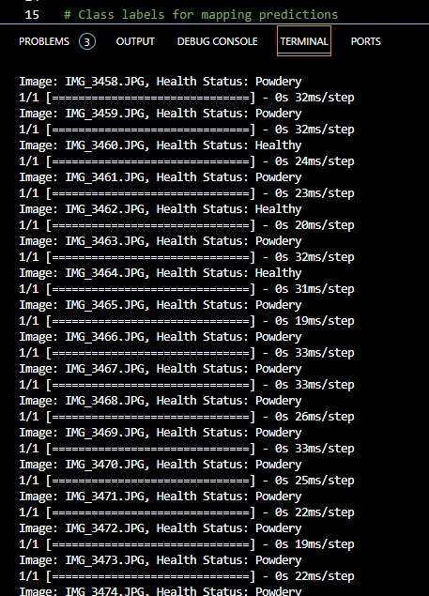

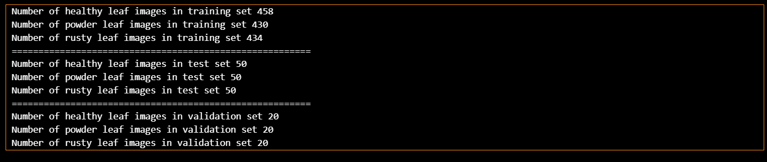

* **Labelled Image View in Side Panel:**
  + - * Incorporating a side panel displaying each image with a labelled view of identified problems.
      * Allowing users to visually verify issues, such as Citrus Canker or fungal viruses, on tree images.
      * 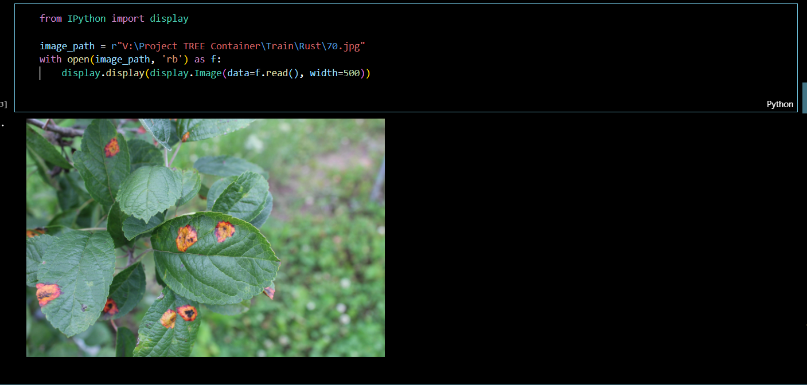Enhancing user understanding and facilitating efficient validation of disease identifications.
* **Mini Heat Map for Disease Spread:**
  + - * Featuring a mini heat map that dynamically plots disease spread based on image data.
      * Enabling users to visually track the progression of diseases in specific areas.
      * Enhancing user awareness of disease patterns and facilitating strategic decision-making.

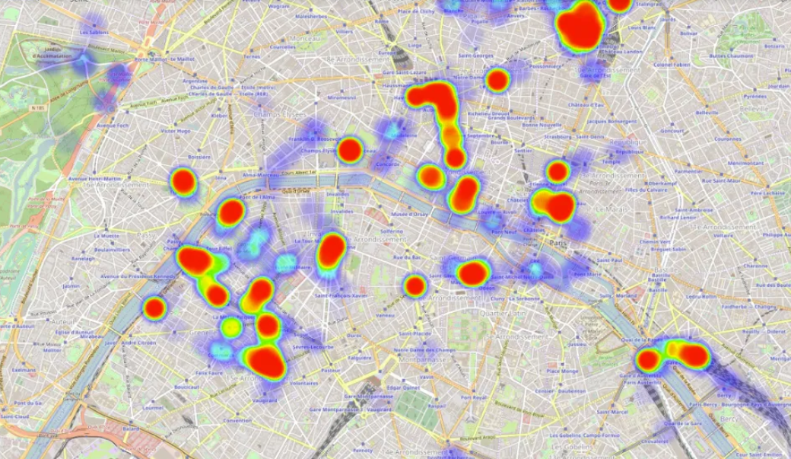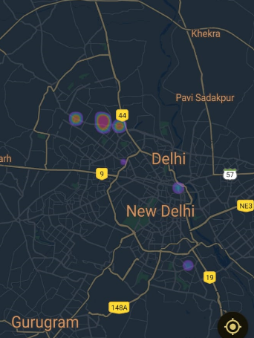

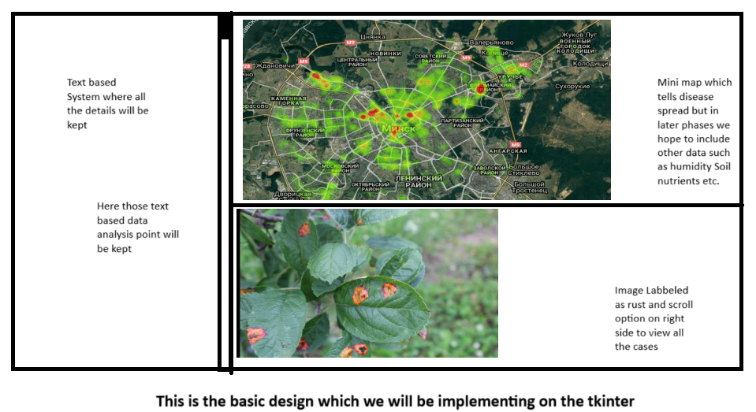

By incorporating these features, our goal is to create a front-end interface that not only enhances usability but also ensures a smooth and efficient experience for the end-users seeking information on the status of specific areas.

This is the starting point in later phases most of these process will be automated sort of like when disease spread or insect infestation is detected the system will automatically plot the image and suggest the mitigation strategy to the user.